**ACD_BDDOF_Session_2_Assignment_1_Main**

**Problem Statement:**

1) Write a java code with the class named ‘acad’ and a method ‘main’. Hard Code the program with two integers and print the sum of those two.

**Java Code:**

Hard coded the two variables and displays sum.

**Output:**

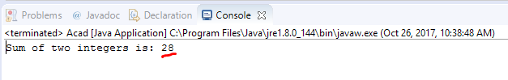

2) Rewrite the above code, where, inputs are provided by the user at runtime and the output is printed.

**Java code:**

Gets the input from user at runtime using Scanner(System.in) and displays sum.



**Output:**

Prompted for two values and then program displayed the sum.



3) Write a program with method name sum() that accepts two parameters from user and print the sum of two numbers.

Output format should be as:

First number is:

Second number is:

Sum is:

**Java code:**

Gets the input from user at runtime using Scanner(System.in) and calls the SUM() function with two parameters. Sum() – performs sum of two inputs



**Output:**

Prompted for two values and then program displayed the sum.



4) Write a program to accepts two numbers from stdin and find all the odd as well as even numbers present in between them.

**Java code:**

Get the two numbers at runtime using Scanner(System.in) and prints the odd(%2!=0) and even no(%2==0) list between the range.

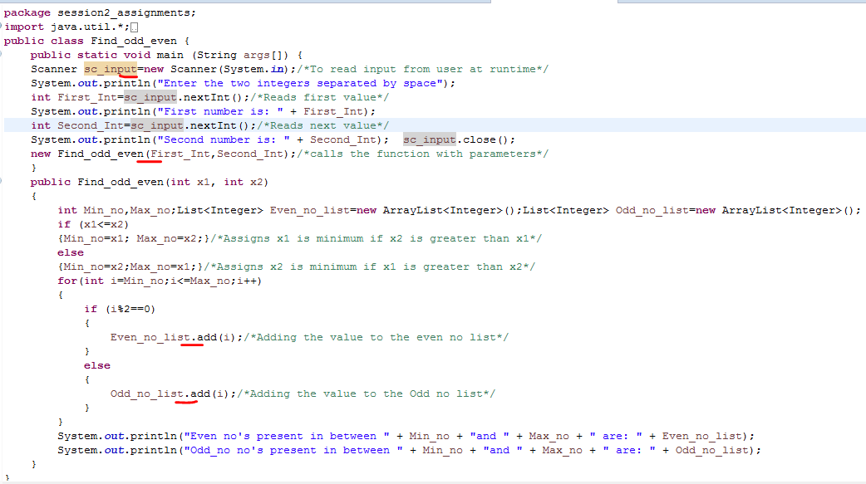

**Output:**

Prompted for two values. And then program assigns second input ‘3’ as min and ’20’ as mix and display odd and even list.



5) Joe is scared to go to school. When her dad asked the reason, joe said she is unable to complete the task given by her teacher. The task was to find

the “first 10 multiples” of the number entered from stdin.

Eg:

Input: 3

O/p:

3 x 1 = 3

3 x 2 = 6

………

3 x 10 = 30 Help Joe in completing the task!

**Java code:**

Get the no for which 10 multiples needs to be displayed using Scanner and displays 10 multiples.



**Output:**



6) Write a program consisting method sum() and demonstrate the concept of method overloading using this method.

**Java code:**

Overloaded the Sum() method either in terms of no of arguments,position of arguments,data type of arguments.



**Output:**

Calls specific funtions according to the overloaded type.

7) Can you overload a method with same return type.? Explain your answer with proper logic.

Yes, we can overload a method with same return type only **if methods are overloaded either interms of number of arguments or order of arguments or** **data type of arguments but cannot be overloaded interms of return type.**

**As Method return type doesn’t matter in case of overloading,** we can overload methods having same return type but **can't overload based on return type.**

Depending on the parameters provided for the method, in the run time, compiler determines which version of the method to execute.

***Example:***

int mymethod(int a, int b)

int mymethod(int var1, float var2) /*overloaded interms of data type of arguments*/

**Result:**

This overloading will work. As overloading is based on **data type of arguments** even though the return type is same(not considered return type in case of overloading). **This way(one way) we can overload method with same return type.**

***Example:***

int mymethod(int a, int b)

float mymethod(int var1, int var2)

**Result:**

Compile time error. Argument lists are exactly same. Even though return type of methods are different, it is not a valid case. Since return type of method doesn’t matter while overloading a method.

An overloaded method may or may not have different return types. But return type alone is not sufficient for the compiler to determine which method is to be executed at run time.

More than one method with same name and argument list cannot be given in a class even though their return type is different.

8) Write a program in java using Arrays, that sorts the element in descending order.

**Java code:**

Gets the number of elements to be added to the array at run time and creates array dynamically.

Sorts the array in descending order.

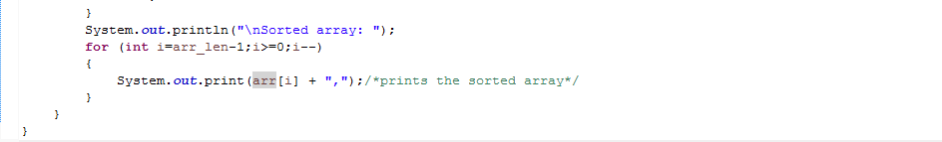

**Output:**

Prompts for no of elements and values to be added to the array. And displays the array in descending order.

